MCM—A The Rapid Plastic Deformation

About thirty years ago, the problem of the localization of rapid plastic deformation of a number of polycrystalline metals into adiabatic shear bands began to receive considerable attention, mainly due to its connection with military applications, such as armor penetration. However, the phenomenon had been observed much earlier in metal machining operations (see Figure 1). At faster cutting speeds and larger depths of cut, the strips of work material, removed by machining, called chips, were often observed to exhibit considerable structure, as a bifurcation took place in the material flow, from continuous, or fairly smooth chips, to serrated, or shear localized chips; see Figure 2(a).

The generally accepted explanation for the onset of this shear localization is that the tendency of a metal to work-harden with increasing deformation is overcome by a competing tendency for the material to soften, due to heat production caused by the rapid shearing. The term adiabatic refers to the fact that the time scale for heat conduction is much larger than the time scale for heat generation by plastic working. Recently, there has been a growing interest in the machining of amorphous metallic alloys, which are also called bulk metallic glasses**非晶态金属** (BMG). These materials differ from common polycrystalline metallic alloys, because their atoms do not assemble on a crystalline lattice, and as a result, they have unique physical, mechanical, and chemical properties. What is interesting is that a number of BMG’s have been found to produce shear-localized chips during machining operations; see Figure 2(b). Furthermore, a number of theoretical studies have argued that this strain localization is controlled not by rapid heating, but rather by a change in the concentration of free volume in the material.

**Please model this problem to:**

**调查非晶态金属形成的剪切带**

* Investigating shear band formation in a BMG by studying a geometrically simple deformation of the material, a homogeneous shear flow.

挖掘一些分析绝热剪切带在更加普通的合金中的形成

* Mimicing some of the analysis that has been done to study adiabatic shear band formation in more common metallic alloys.

均匀剪切流动的线性稳定性分析

* Performing a linear stability analysis of the homogeneous shear flow.

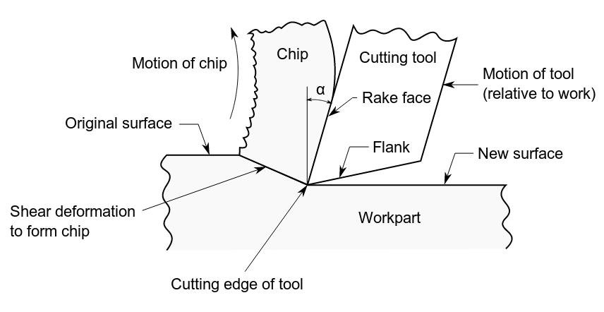

Figure 1. Schematic of a cutting process. The cutting tool moves across the workpart and a chip is formed in front of the tool.

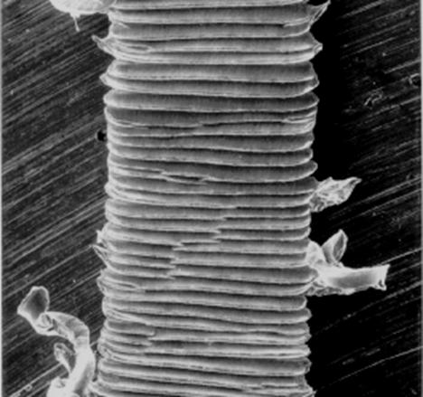 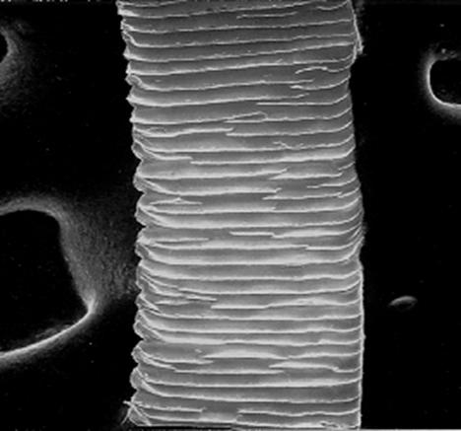

(a) 52100 Bearing Steel (Grain Size:10’s of μm) (b) Nickel=Phosphorus (Amorphous)

Figure 2. Chips from two materials being machined.

MCM—B Bridging Land-Use and Algal-Booms

The goods and services that lakes provide result from complex interactions between meteorology, hydrology, nutrient loads and in-lake processes. Hydrology and nutrient loads are, in turn, influenced by socio-economic factors such as human habitation, water abstraction and land-management, within their catchments.

Please modeling a appropriate model to provide a means of linking these different domains and also of forecasting and evaluating the effects of different management scenarios on lakes.

Then describes the application of such models to ChaoHu, for the sake of a well-studied lake with water quality problems in the Hefei Lake District.

**These tips shoul be noted:**

土地管理方案对水质的影响

* your models should forecast impacts of land management scenarios on lake water quality.

本地数据及观点应当集成至你的模型

* Local inputs and expert knowledge should be incorporated into your models.

为方案提供水质和有害水文预测

* Water quality and potentially-toxic algal blooms should be forecast for the scenarios.

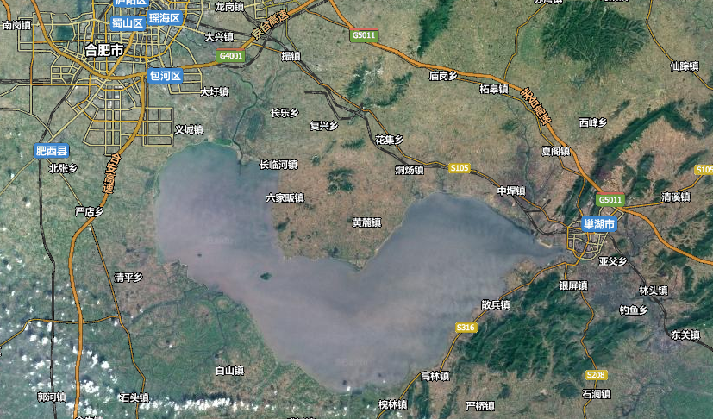

Figure 1. The overview of ChaoHu.